


Temenos T24™

FUNCTIONAL SPECIFICATION DOCUMENT

[Running Finance]

Document History

Author | Version | Date | Comment
Majid Ali | 1.0 | 30-12-2021 | Updated

Document Sign Off

Date | Version | Name | Company / Position

Sign-off (Solution / FSD)
<This section is to update the mutual sign-off on the FSD between Temenos and Client>

Contact Person | Role / Organization | Date | Signature

Table of Contents
1. Introduction 5
2. Reference Documentation 5
3. Requirement Overview 5
4. Existing Functionality 6
5. Gaps 6
WS04-AL-17 6
WS04-AL-13 6
WS04-AL-24 6
6. New Functionality 7
WS04-AL-17 7
WS04-AL-13 8
WS04-AL-24 8

Introduction

The document contains the requirements and FSD of Running Finance.

Reference Documentation
Business Process review sheet is attached that is completed after discussion with Bank.

Document Name | Embedded Document | Author, Company
Business Process Review |  | Majid Ali

Requirement Overview

Gap Number | Description | Process
WS04-AL-17 | Bill Type | Overdraft facility with contract ageing of markup bill due on monthly. This account will also be used as normal current account. A Limit will be granted to all Running Finance account holders.
WS04-AL-13 | Accruals | Markup needs to be accrued on daily based on Debit reflection on RF accounts. A bill of mark-up will issued on monthly basis based on their debit balance. If the bill is unpaid, an aging on contract level is required that will further be used for asset classification, provisioning and income suspension.
WS04-AL-24 | Payment Type | Any Credit transaction should be net off with debit balance on RF account and therefore, markup needs to accrue accordingly. For Interest bill Payment any CASA Account can be used. INTEREST due on monthly and PRINCIPAL on maturity but if user wants to settle early then principal will settled accordingly.

Existing Functionality
Currently any T24- AA module cannot single-handedly support the above mentioned requirements, therefore, a hybrid framework of AA Accounts and AA lending needs to be designed to cater above functionality.

Gaps

WS04-AL-17
Overdraft facility with contract ageing of markup bill due on monthly. This account will also be used as normal current account. A Limit will be granted to all Running Finance account holders.

WS04-AL-13
Markup needs to be accrued on daily based on Debit reflection on RF accounts. A bill of mark-up will issued on monthly basis based on their debit balance. If the bill is unpaid, an aging on contract level is required that will further be used for asset classification, provisioning and income suspension.

WS04-AL-24
Any Credit transaction should be net off with debit balance on RF account and therefore, markup needs to accrue accordingly. For Interest bill Payment any CASA Account can be used. INTEREST due on monthly and PRINCIPAL on maturity but if user wants to settle early then principal will settled accordingly.

New Functionality

WS04-AL-17
Overdraft facility with contract ageing of markup bill due on monthly. This account will also be used as normal current account. A Limit will be granted to all Running Finance account holders.

Solution
For every Running Finance facility there would be two accounts. One will be opened in AA Accounts and other will be opened in AA Lending and this will be used and one to one mapping rule. Below local mapping table will be used for validation.
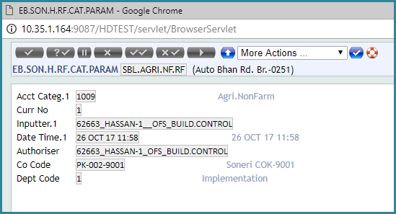

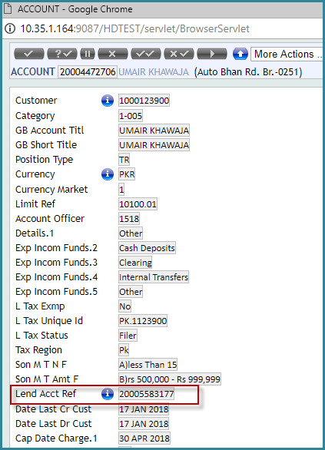
For every AA Account, there is a local reference in AC application named as LEND.ACCT.REF. This local reference should be used to store the account reference of each RF AA Lending account.
Whenever, a customer will be requested for RF facility, a new RF AA lending Account will be created. On activity LENDING-NEW-ARRANGEMENT, a routine will be fired that will write the account reference of AA lending account in this local filed. Moreover, the limit reference that user will park in AA lending account this same limit reference will also be written on customer’s AA account through this routine.
When the user will requested to close it RF facility, a routine will be attached to LENDING-MATURE- ARRANGEMENT activity. This routine will throw error if there would be any payable in customer’s AA
Account. Also this routine will make blank the above local ref LEND.ACCT.REF and remove the limit reference from AA Account.

WS04-AL-13
Markup needs to be accrued on daily based on Debit reflection on RF accounts. A bill of mark-up will issued on monthly basis based on their debit balance. If the bill is unpaid, an aging on contract level is required that will further be used for asset classification, provisioning and income suspension

Solution
The debit reflection of AA Account will be moved to AA lending Account, CR AA Account DR AA Lending in each COB before the date change. And whenever there is a credit transaction in AA Account a sweep transaction will automatically be generated that will DR AA Account and CR AA Lending. The transaction amount of this sweep will not be exceeded to the DR amount presented in AA Lending. (NO UNC).

WS04-AL-24
Any Credit transaction should be net off with debit balance on RF account and therefore, markup needs to accrue accordingly. For Interest bill Payment any CASA Account can be used. INTEREST due on monthly and PRINCIPAL on maturity but if user wants to settle early then principal will settled accordingly.

Solution
In AA Accounts of RF a routine needs to be placed on activity ACCOUNTS-CREDIT-ARRANGEMEN against the property class ACCOUNT and action CR.MOVEMENT. Whenever there is a credit transaction in AA Account a sweep transaction will automatically be generated that will DR AA Account and CR AA Lending. The transaction amount of this sweep will not be exceeded to the DR amount presented in AA Lending. (NO UNC)

